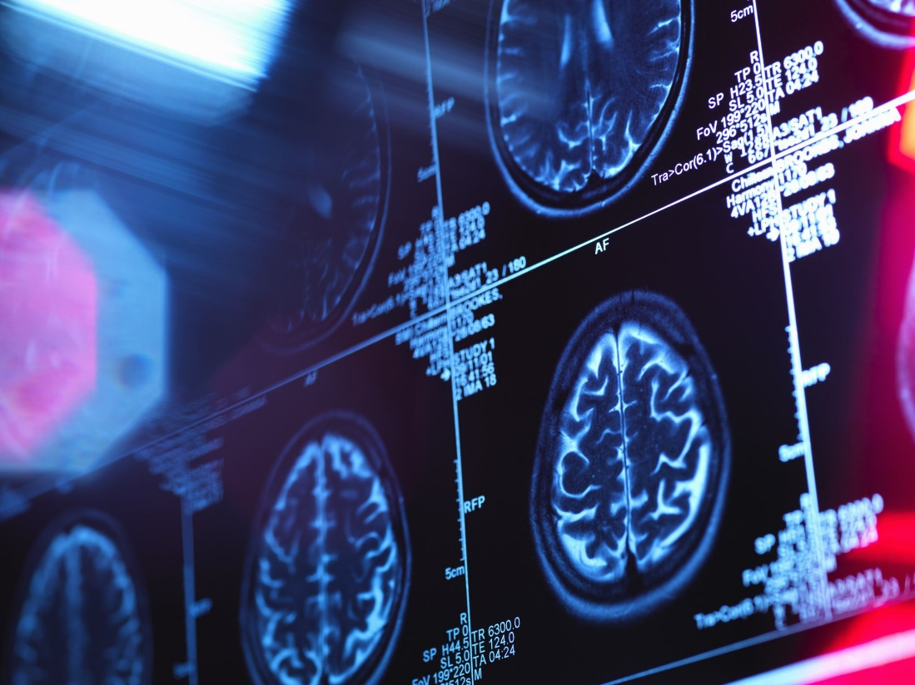

Imaging-Analysis Laboratory Technical Onboarding

Table of Contents

- Introduction

- Getting Started on the Cluster

- Independent Component Analysis (ICA) - Background, Software, and Resources

- Additional Tools

- Databases

- Introduction

Welcome to the TReNDS Imaging-Analysis laboratory (Principal Investigator: Armin Iraji, Ph.D.)! This document is intended to assist you as you begin working with our group. Within, you’ll find an agglomeration of resources geared toward familiarizing you with some of our core technical approaches to the study of brain function and disease in addition to some helpful materials for getting started on the TReNDS computing cluster. Please note that this document isn’t intended to be exhaustive but is rather meant to serve as a beginning point for undergraduate, graduate, and postdoctoral researchers in need of technical assistance. It is important to remember that you may always reach out to fellow group members and researchers along the lines delineated within our laboratory handbook if you require assistance with research obstacles not detailed here.

Principal Investigator: Armin Iraji, Ph.D.

Personal Page: Home (google.com)
Google Scholar: https://scholar.google.com/citations?view_op=list_works&hl=en&hl=en&user=e35VA6sAAAAJ&sortby=pubdate

- Getting Started on the Cluster
We advise you to take steps toward getting started on the computing cluster right away. You can find detailed guidance on getting started here:
https://trendscenter.github.io/wiki/docs/Getting_Started.html
It is important for you to begin working on setting up your cluster configuration for multiple reasons:
- Setting up a working configuration involves several steps and can take time.

- In the event you require troubleshooting assistance, taking steps early gives those who can assist your ample opportunity to do so.

- Discovering configuration difficulties during time-sensitive research efforts can be counter-productive and de-rail your progress, resulting in an inability to meet deadlines.

Please also take some time to review the general TReNDS cluster documentation:
https://trendscenter.github.io/wiki/
The general documentation contains answers to FAQs, provides guidelines on resource sharing and job submission, contains a list of DOs and DON’Ts, and lists the software and modules currently available for use on the cluster. We commonly work within the MATLAB software environment.
You’ll also find helpful pins on our Slack channel that provide additional instructions on job submission. For example, here you can find some guidelines on syntax as well as a template for the submission of a single job.

- Independent Component Analysis (ICA) - Background, Software, and Resources
Independent component analysis (ICA) is one of our core approaches to the study of neuroimaging data. ICA, which is related to the problem of blind source separation (BSS), standardly assumes that the data of interest is a linear mixture of statistically independent, non-gaussian source signals. Consider a matrix $X_{m×n}$ given by the ICA model.
$$X = AS$$
where $A_{m×c}$ is an unknown mixing matrix and $S_{c×n}$ represents the source signals (Calhoun et al., 2009). ICA aims to find an unmixing matrix $W_{c×m}$ which yields optimal approximations to the source signals $Y_{c×n}$ such that.
$$Y = WX$$

In the Imaging-Analysis laboratory, we frequently apply ICA to functional magnetic resonance imaging (fMRI) data to obtain network representations that can be considered estimates of the data’s functionally connected sources. When ICA is applied at the group level (GICA), it allows us to obtain representations of common networks which can then be estimated for specific subjects.
If you are unfamiliar with the application of ICA either more generally or within a neuroimaging context, we recommend familiarizing yourself with our Group ICA of fMRI Toolbox (GIFT) software and the related documentation here. You may also find the following links to the GIFT manual, walkthrough, and video tutorial useful.
We encourage you to review the following additional resources on ICA, functional connectivity (FC), and fMRI:
Calhoun, V. D., Liu, J., & Adali, T. (2009). A review of group ICA for fMRI data and ICA for joint inference of imaging, genetic, and ERP data. NeuroImage, 45(1 Suppl), S163–S172. https://doi.org/10.1016/j.neuroimage.2008.10.057
Iraji, A., Faghiri, A., Lewis, N., Fu, Z., Rachakonda, S., & Calhoun, V. D. (2021). Tools of the trade: estimating time-varying connectivity patterns from fMRI data. Social cognitive and affective neuroscience, 16(8), 849–874. https://doi.org/10.1093/scan/nsaa114
Soares, J. M., Magalhães, R., Moreira, P. S., Sousa, A., Ganz, E., Sampaio, A., Alves, V., Marques, P., & Sousa, N. (2016). A Hitchhiker's Guide to Functional Magnetic Resonance Imaging. Frontiers in neuroscience, 10, 515. https://doi.org/10.3389/fnins.2016.00515

- Additional Tools

  - Writing Data to Nifti Format
  - Cluster Matching
  - Identifying and Labeling Networks
The brain is a complex organ composed of various regions that communicate and work together to perform cognitive, sensory, motor, and other functions. Brain networks can generally be categorized into two types: structural networks and functional networks. Structural networks are based on the physical connections between brain regions, while functional networks are based on statistical relationships between brain region time courses while performing tasks or during rest.
We use several methods to identify and label these networks. The following figure shows spatial maps of 12 large-scale functional brain networks commonly obtained from spatial independent components analysis (sICA).
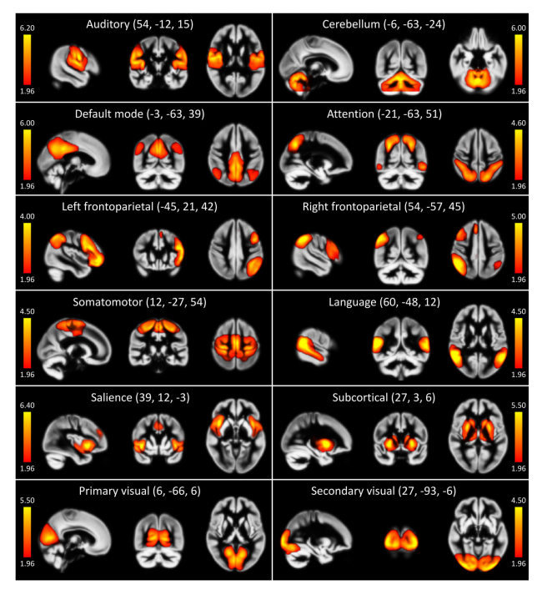
From Iraji et al. (2019)

We encourage you to review the following resources on identifying and labeling networks:
Elena A. Allen, Erik B. Erhardt, Eswar Damaraju, William Gruner, Judith M. Segall1, Rogers F. Silva, Martin Havlicek, Srinivas Rachakonda, Jill Fries, Ravi Kalyanam, Andrew M. Michael, Arvind Caprihan, Jessica A. Turner, Tom Eichele, Steven Adelsheim, Angela D. Bryan1, Juan Bustillo, Vincent P. Clark1, Sarah W. Feldstein Ewing, Francesca Filbey, Corey C. Ford, Kent Hutchison, Rex E. Jung, Kent A. Kiehl, Piyadasa Kodituwakku, Yuko M. Komesu, Andrew R. Mayer1, Godfrey D. Pearlson, John P. Phillips, Joseph R. Sadek, Michael Stevens, Ursina Teuscher, Robert J. Thoma,and Vince D. Calhoun1(2011). A baseline for the multivariate comparison of resting-state networks. DOI: 10.3389/fnsys.2011.00002
Armin Iraji, Thomas P. Deramus, Noah Lewis, Maziar Yaesoubi, Julia M. Stephen, Erik Erhardt, Aysneil Belger, Judith M. Ford, Sarah McEwen, Daniel H. Mathalon, Bryon A. Mueller, Godfrey D. Pearlson, Steven G. Potkin, Adrian Preda, essica A. Turner, Jatin G. Vaidya1, Theo G. M. van Erp, Vince D. Calhoun (2019). The spatial chronnectome reveals a dynamic interplay between functional segregation and integration.
DOI: 10.1002/hbm.24580

GIFT manual

  - Statistical Comparisons
  - Fitting a General Linear Model (GLM)
  - Data Visualization
  - Visualizing functional connectogram
Visualizing data in a revealing, appealing way is increasingly important. There are multiple tools available to you for visualizing images of the network representations extracted from ICA and the results of voxel-wise statistical comparisons.
GIFT contains an “Image viewer” utility that is straightforward and easy to use. After writing your data to an image format (such as. nii) and loading the GIFT GUI, you can display images from GIFT’s Image viewer by clicking on the “Display Tools” central drop-down menu.

Option 1: https://www.mathworks.com/matlabcentral/fileexchange/48576-circulargraph, You can use this function (here is one example) to plot if Circos (http://circos.ca/) doesn't work for you.
Option 2: From the GIFT toolbox, you can also plot a connectogram with the function icatb_plot_connectogram.

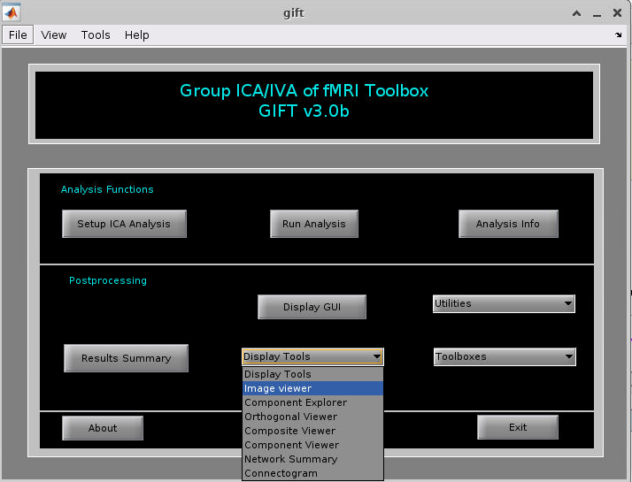
You will then be prompted to select the images that you wish to visualize.
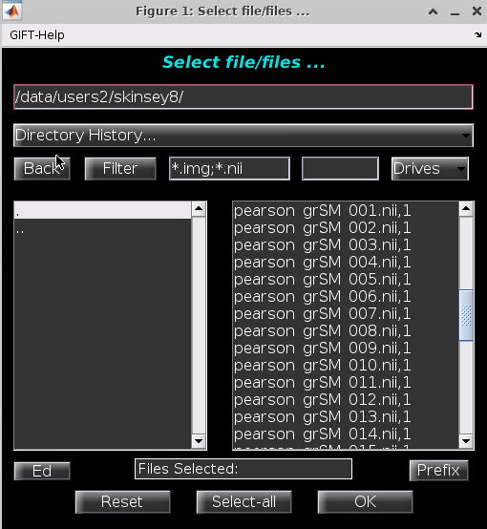
After selecting the image files, you will be prompted to select display options including display type, image Z-scoring, thresholding, and additional parameters.
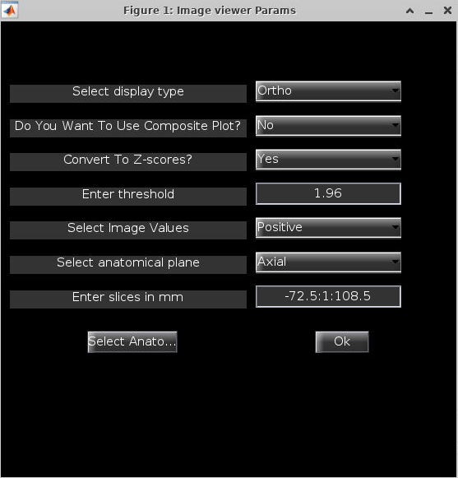
After selecting “Ok,” GIFT displays the chosen images according to the display parameters.
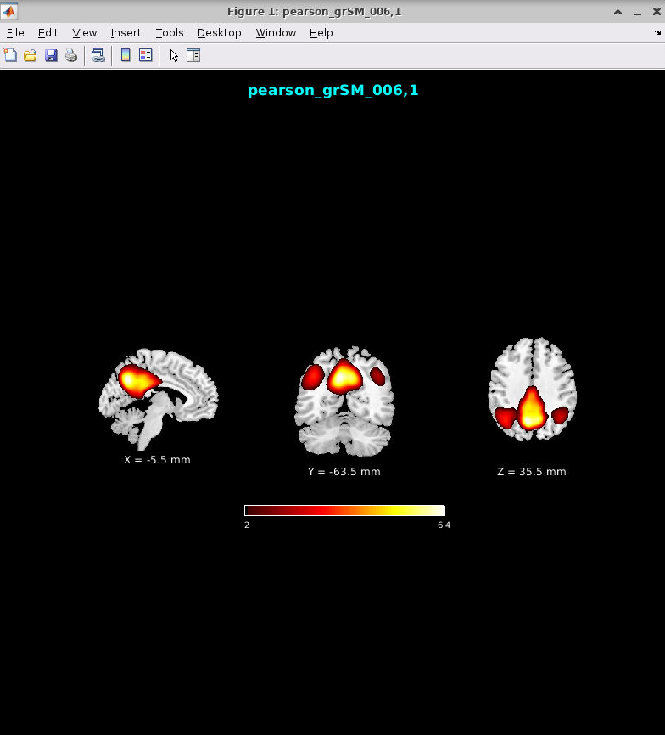

You may also wish to display subthreshold values along with contour-delineated suprathreshold values, which can be especially useful and informative when visualizing the results of statistical comparisons. The figure below compares the suprathreshold-only display approach (left) to the dual coded subthreshold and suprathreshold approach (right).
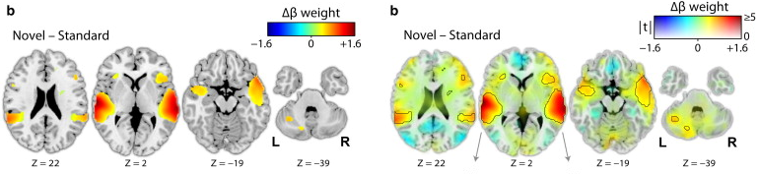
From Allen et al. (2012)
Clearly, the dual coded visualization approach provides readers with a more complete depiction of the results by revealing subthreshold trends toward significance.
Sample code for generating dual coded images can be found in Allen et al. (2012). Please also feel free to reach out to Spencer Kinsey (skinsey8@gsu.edu) if you are interested in implementing this approach.
Additionally, MRICroGL/MRICron is an incredibly useful visualization tool for fMRI as well as structural MRI (sMRI) data. MRICroGL is available for download on NITRC here.
We encourage you to review the following resources on data visualization:
Allen, E. A., Erhardt, E. B., & Calhoun, V. D. (2012). Data visualization in the neurosciences: overcoming the curse of dimensionality. Neuron, 74(4), 603–608. https://doi.org/10.1016/j.neuron.2012.05.001
Taylor, P. A., Reynolds, R. C., Calhoun, V., Gonzalez-Castillo, J., Handwerker, D. A., Bandettini, P. A., Mejia, A. F., & Chen, G. (2023). Highlight results, don't hide them: Enhance interpretation, reduce biases and improve reproducibility. NeuroImage, 274, 120138. https://doi.org/10.1016/j.neuroimage.2023.120138
GIFT manual
MRICroGL main documentation

- Databases

There are many codes and software can be available from TReNDS GitHub (Center for Translational Research in Neuroimaging and Data Science · GitHub), and we strongly suggest you explore it, and it can help you familiar related code and soft.

To effectively start your project, we suggest that you go check the databases we have so far, and most of them are in the cluster. Go to check section 2, set up an account, and go to assess databases.

Some brain network templates can be obtained from: Data - TReNDS (trendscenter.org)

